Future forms: “**will**” a snap decisions and “going to” a future intention. Question tags.

**FUTURE WITH WILL:** SNAP DECISIONS

*Positive form*: **I’ll (I will) + infinitive**

I’ll try it!

I’ll come back later!

*Negative form*: **I won’t /uount/(I will not) + infinitive**

I won’t buy it!

I won’t pay by cash!

*Question form*: **Shall I + Infinitive**

Shall I do it?

Shall I help you?

**Shall** -> deberá

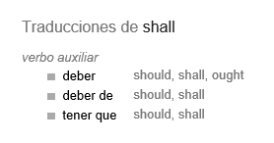

**FUTURE WITH “GOING TO”** Speaking about future plans and intentions:

*Positive form*: **To be + going to + infinitive**

I’m going to have some tea

She’s going to sing well

They’re going to take the tuve

* Now very often, when your hear this form, you hear a pronunciation like “**gonna**”:

They gonna take the tuve,

And that’s when we completely contract “They are going to” and it becomes “gonna”.

*Negative form:* **to be + not + going to + infinivite**.

I’m not going to leave tomorrow

He isn’t going to return son

We aren’t going to come with you

* Sometimes you hear “I’m not gonna”, that’s when we speak quickly. *It’s the contraction of : “going to”*

*Question form:* **to be + subject + going to + infinitive**

How are we going to get there?

Where is it going to happen?

When are they going to leave?

How are we gonna get there?